**Group 22 Testing Documentation**

Page 2 – Account Functionality

Page 12 – Marketplace

Page 19 – Search Bar

Page 20 – Forum Chat

**Account Functionality**

**Log-In Page:**

Case 1: Attempting to Log In with an email that is not registered raises an error message.

Case 2: Attempting to Log In with an invalid email raises an error message that says you must include an ‘@’ symbol.

Case 3: Entering an incorrect password for the given e-mail address will raise an error message.

Case 4: Entering the correct password for a given email address will successfully log in the user and send them to the marketplace homepage.

**Sign-Up:**

Case 1: If the user enters an email that is less than 3 characters, then an error message shows.

Case 2: Attempting to Log In with an invalid email raises an error message that says you must include an ‘@’ symbol.

Case 3: Attempting to sign up with an email that is already registered raises an error.

Case 4: Entering a username less than 2 characters raises an error.

Case 5: Entering a username that is already taken raises an error.

Case 6: Entering passwords that do not match raises an error.

Case 7: Entering matching passwords that are less than 7 characters raises an error.

Case 8: If the user does not do any of the previous 7 errors, then they will be successfully signed up.

**Change Username:**

Case 1: An error is raised when you try to change your username to your current one.

Case 2: An error is raised if you enter a new username less than 2 characters.

Case 3: Error is raised if you try to enter a username that is already taken.

Case 4: If the usernames do not match an error is raised.

Case 5: If the 4 above cases are avoided, the username is successfully changed.

**Change Password:**

Case 1: If the passwords do not match, an error is raised.

Case 2: If the new password is the same as the old one, an error will be raised.

Case 3: If the password is less than 7 characters an error will be raised.

Case 4: If the above three cases are avoided, the password will be updated.

**Delete Account:**

Case 1: If you enter the wrong password, an error is raised.

Case 2: If the password is correct, the account is deleted.

**Marketplace**

**Add a Card:**

Case 1: If there is invalid input such as a negative price or non-alphabet character in the Listing Name, then an error will be raised.

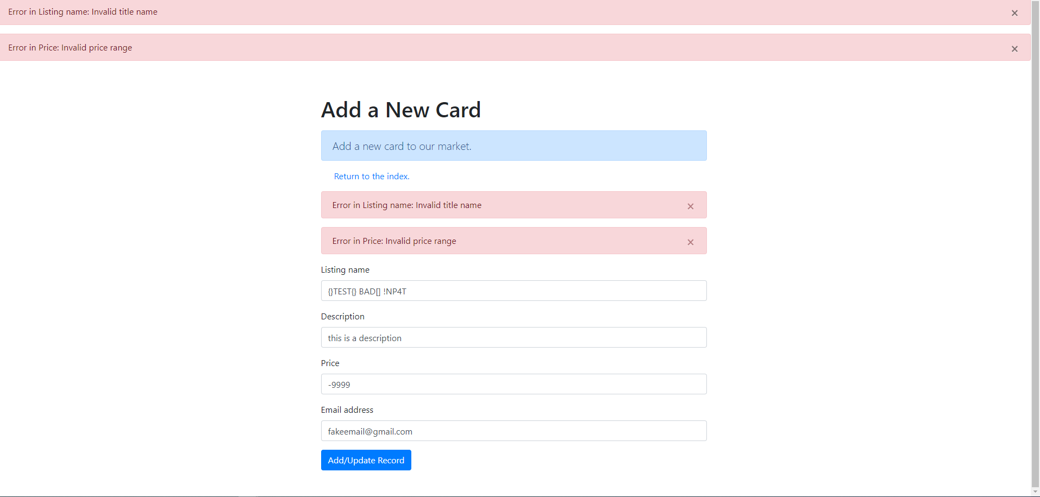

Case 2: This case shows that the system will not allow SQL injections.

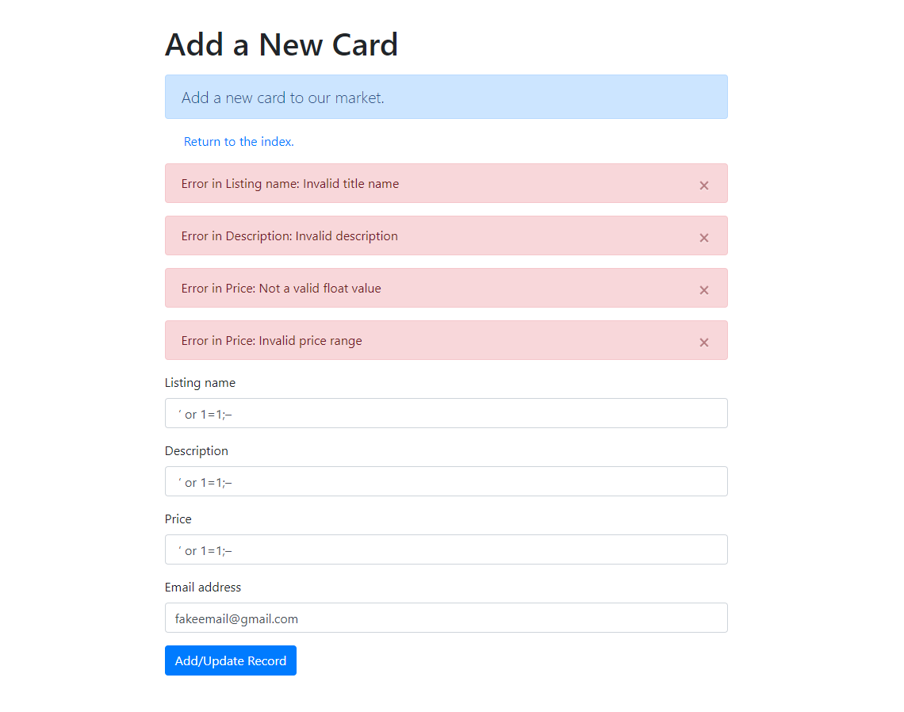

Case 3: An additional case that shows how it prevents additional SQL injections

Case 4: The form will not allow blank entries to be submitted as an error will be raised.

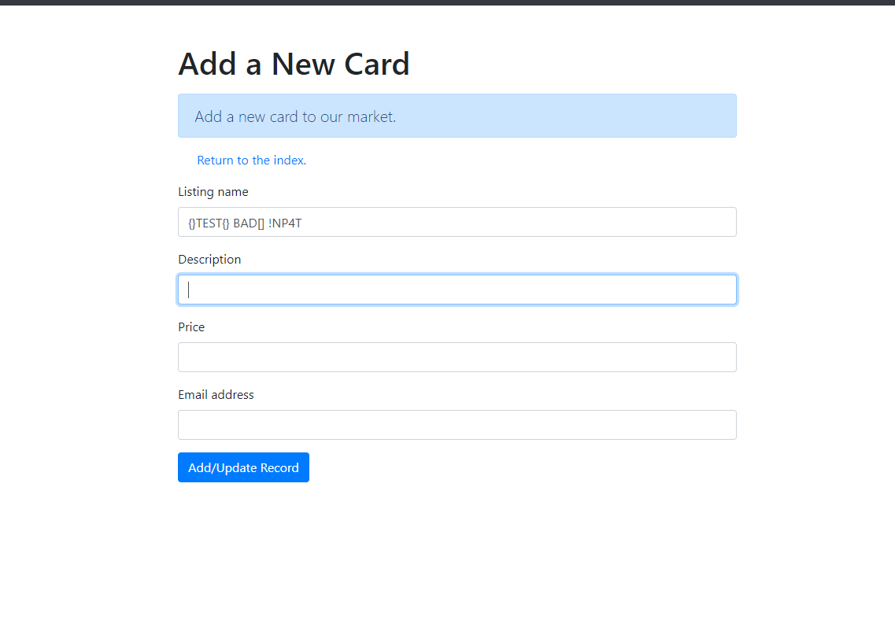

Case 5: The first picture shows what a valid card would look like. The second screen shows what the user will see after adding the card to the marketplace.

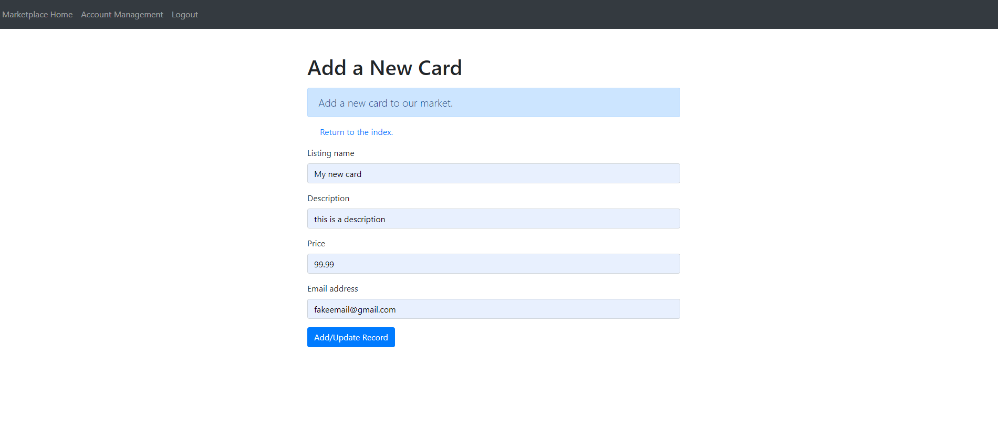

**Edit Card:**

Case 1: An error is raised when you enter an invalid price.

Case 2: If the listing name is a SQL injection, as it is below, an error will be raised.

Case 3: All fields must be valid as they are in the first picture, to get to the success screen in the second picture below.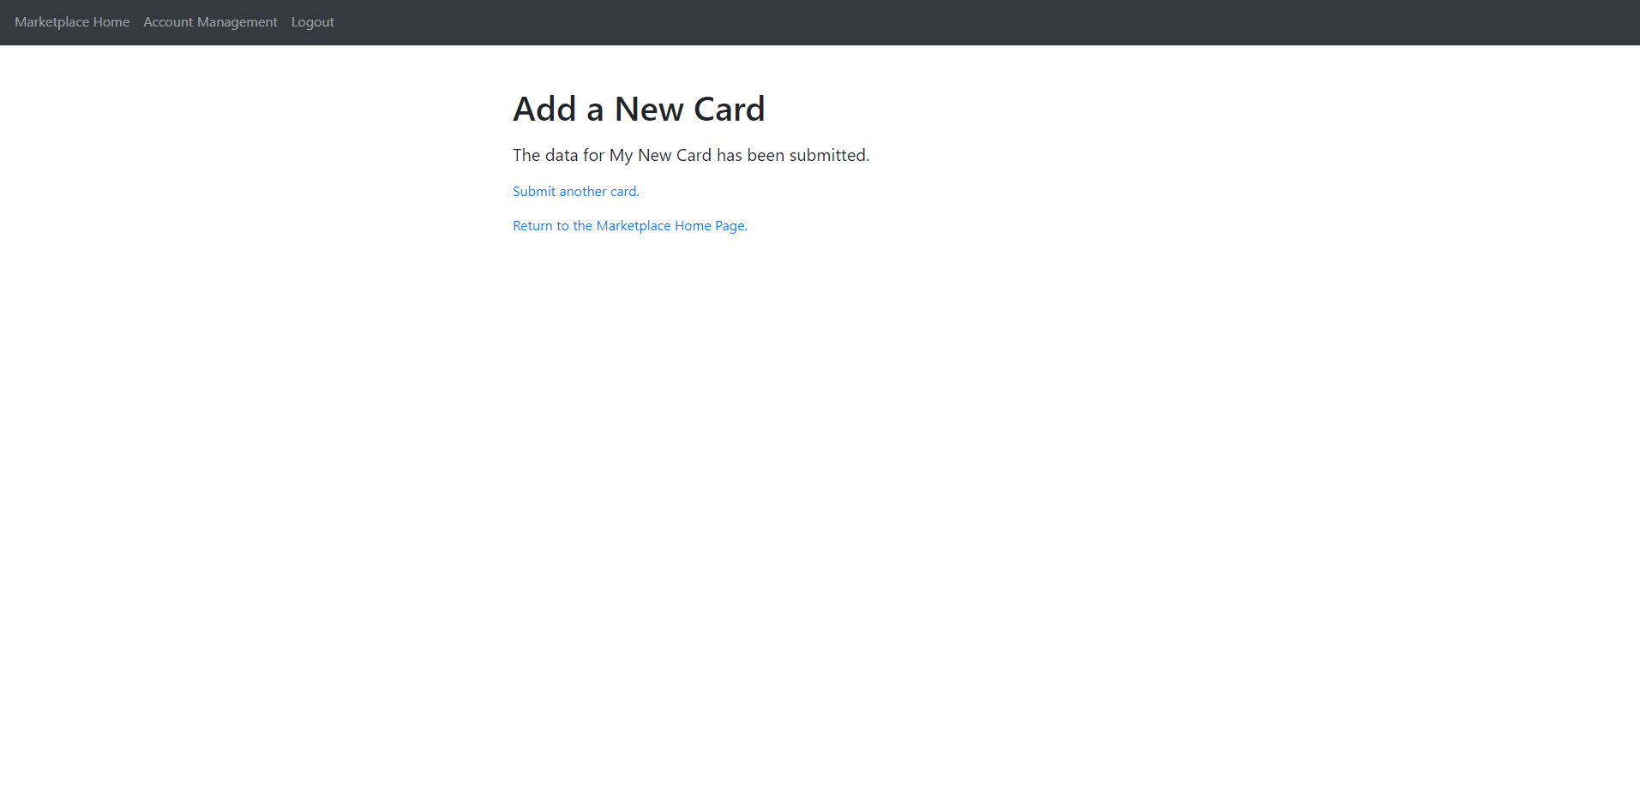

**Select a Card:**

Case 1: If you try to submit choice without selecting a card, an error will pop-up.

Case 2: If you properly select a card and press submit choice you will be sent to either the delete it or edit it screen depending on your choice.

**Delete a card:**

Case 1: You have chosen a card to delete, and you press “delete this card”. You will get redirected to a confirmation message affirming the result.

**Search Bar:**

Case 1: The search is not case sensitive. When searching “BALL”, players named “Ball” still appear.

Case 2: Searching for a player that does not exist. In this case, someone named “balla”.

**Forum Chat:**

Case 1: The page loads correctly for forumchatpage.html with two text boxes and a submit button.

Case 2: The text boxes are working, and text is able to be input into the appropriate places.

Case 3: A failure case in which the mainforum.py fails to link to the forumchatpage.html file.

